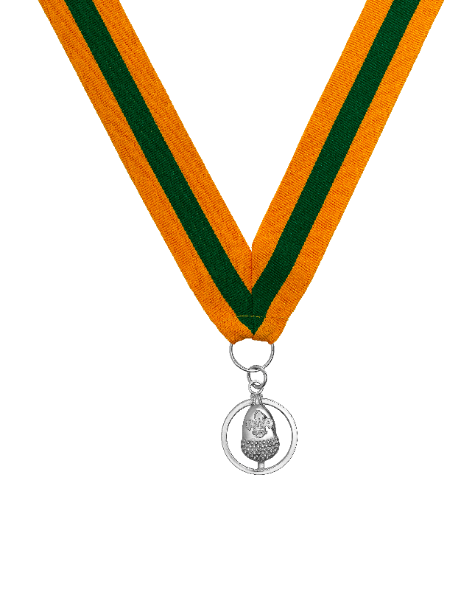
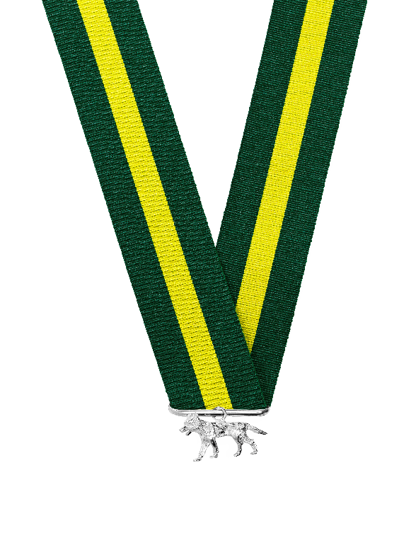
Bar to the Silver Acorn and Silver Wolf nomination form
The purpose of this form is to nominate an individual for an award. This form is used to collect personal data about you and the individual being nominated.

We take personal data privacy seriously. The data you provide is managed and carefully kept in line with our Data Protection Policy. This personal data may be shared with other relevant Scout members for the purpose of assessing the award nomination. Make sure the nomination form is only shared locally in accordance with the guidance below.

Details of successful awards will be uploaded to an individual’s Compass record and published annually on scouts.org.uk/awards. The UK Headquarters Awards Team will share relevant data with other UK Headquarters teams for appropriate national event invitations. The UK Headquarters Awards Team will also securely store (electronically) the details for one year from the end of the awarding process (or longer if required for national event invitations), before they’re passed to the UK Headquarters Heritage Team for their records. Local nomination forms should be kept for 12 months in line with UK Headquarters timeline, and securely destroyed after this period. This is in case they’re needed for further queries from the Awards Team.

Last updated 01/11/2021
scouts.org.uk/awards
#SkillsForLife

Once the form is completed by the nominator

For England/Wales:

- If the nominee holds their primary appointment in a Group/District, this form should be sent to the relevant District Commissioner for support (see ‘Supporter A’ section below), and then to the relevant County/Area Commissioner for their additional support (see ‘Supporter C’ section below).

- If the nominee is a District Commissioner, or their primary appointment is in a County/Area, this form should be sent to the relevant County/Area Commissioner for support (see ‘Supporter C’ section below).

- If the nominee is a County/Area Commissioner, this form should be sent to the relevant Regional Commissioner for support (see ‘Supporter C’ section below).

- If the nominee is a Region Commissioner, this form should be sent to the Chief Commissioner of England/Wales for a decision (see ‘Supporter C’ section below).

For Headquarters volunteers:

- If the nominee is a national volunteer, this form should be sent to the relevant member of the UK Leadership Team or the Chair of the relevant UK Board Subcommittee for support (see ‘Supporter B’ section below), and then to either the UK Chief Commissioner or the Chair/Vice Chair of the UK Trustee Board for support (see ‘Supporter C’ section below).
For Northern Ireland/Scotland:

- If the nominee holds their primary appointment in a Group/District, this form should be sent to the relevant District Commissioner for support (see ‘Supporter A’ section below), and then to the relevant County/Region (Scotland) Commissioner for their additional support (see ‘Supporter B’ section below), and then to the relevant Country Headquarters for further support (see ‘Supporter C’ section below).

- If the nominee is a District Commissioner, or their primary appointment is in a County/Region (Scotland), this form should be sent to the relevant County/Region (Scotland) Commissioner for support (see ‘Supporter B’ section below), and then to the relevant Country Headquarters for additional support (see ‘Supporter C’ section below).

If the nominee is a County/Region (Scotland) Commissioner, this form should be sent to the relevant Country Headquarters for support (see ‘Supporter C’ section below).

For Headquarters staff:

- If the nominee is a UK Headquarters staff member, this form should be sent to the relevant member of the Executive Leadership Team (UK Headquarters) for support (see ‘Supporter B’ section below), and then to the Chief Executive (UK Headquarters) for additional support (see ‘Supporter C’ section below).

- If the nominee is a Country Headquarters staff member, this form should be sent to the lead staff member (Country Headquarters) for support (see ‘Supporter C’ section below).

Note: Commissioners can delegate the decision making process to a Deputy or their Local Awards Advisory Group.

Contact details are available from the Scout Information Centre (Info.Centre@scouts.org.uk or 0345 300 1818).

Nominee’s details
Please note: The 'Name' listed on Compass (not 'Known As') is used for certificate printing so if a 'Name' amendment is required please email this request to awards@scouts.org.uk.
Membership number Click/tap here to enter membership number
Name Click/tap here to enter name (Forename Surname)
Location (County/Area/Region) Select County/Area/Region
Location (District) Select District
Award nomination Select award
Award preference Select preference

Nominator’s details
A minimum of one nominator and one supporter (who are different individuals) must provide support for this nomination before submitting it to UK Headquarters.

A nomination for these awards can be initiated by anyone but then must be supported by the relevant individuals as laid out in the ‘Once the form is completed by the nominator’ section.

Membership number (if relevant) Click/tap here to enter membership number
Name Click/tap here to enter name (Forename Surname)
Email Click/tap here to enter email address

Checklist
The nominator must check the below boxes to confirm the individual being nominated meets the following criteria:

☐ The nominee holds a volunteer appointment as a member or associate member of the Scouts.
☐ The nominee has enough service for the award they’re being nominated for:
- Bar to the Silver Acorn requires a further five years of specially distinguished service after receiving the Silver Acorn.
- Silver Wolf is seldom awarded for less than 30 years service.
- (Roles that don’t accrue service can’t be counted for this.)
☐ The nominee has a valid disclosure (if relevant for their active roles).
☐ The nominee has not received a Good Service Award in the last five years.
☐ The nominee does not already have the award they are being nominated for.
☐ The nominee has completed all mandatory training (including Wood Badges) relevant to all active roles (or is within three years of appointment to the active roles).
- If the nominee was previously awarded a Wood Badge for the same role as one of their active roles, Compass must be updated to reflect the training of the active role as being up-to-date.
☐ (If relevant) The nominee does have the correct previous Good Service Award for the award they’re being nominated for:
- Bar to the Silver Acorn requires the nominee to have received the Silver Acorn.

Nominee’s previous awards
Please list the most recent previous awards achieved by the nominee.
Type of award Name of award Date
Length of Service Award Select award Select or click/tap here to enter date
Good Service Award Select award Select or click/tap here to enter date

Please provide a screen shot of the nominee’s current and previous adult appointments as listed on Compass.
Click/tap the placeholder below to add the required image


Citation concerning the nominee
Provide a detailed summary below explaining, with examples, what the nominee has achieved in their roles. Citations should be based on fact and the personal data given should be limited to only what’s necessary to make the nomination. (For guidance on citation writing, please visit scouts.org.uk/awards.)

Main role in Scouts
Outline what this role involves and the time commitment the nominee puts in.
Click/tap here to enter text

Service in addition to their main role in Scouts
Outline what’s involved in any other roles in Scouts and the time commitment the nominee puts in.
Click/tap here to enter text

Key achievements
Outline specific achievements and impact of the nominee since their last Good Service Award. Examples could include how they’ve: helped grow membership, raised funds, managed large projects or rebuilt their headquarters, etc. Please quote specific figures where possible.
Click/tap here to enter text

Level of service
Where a previous Good Service Award is held, please outline whether the nominee has continued to provide service at a similar level or whether you believe the quality/complexity of their service has substantially increased and why.
Click/tap here to enter text

Community involvement
Outline any involvement that the nominee has with other organisations since their last Good Service Award. Highlight if this involvement has directly benefitted Scouts.
Click/tap here to enter text

Any other relevant information
Click/tap here to enter text

Click/tap the placeholder below to add an image (if relevant)

Supporter’s details
A minimum of one nominator and one supporter (who are different individuals) must provide support for this nomination before submitting it to UK Headquarters.

Support will be required at all relevant levels before the nomination is sent to UK Headquarters. Please refer to ‘Once the form is completed by the nominator’ section for clarification on who needs to complete this section.

Supporter A (if required)
☐ If nominee has roles in multiple locations, I’ve consulted the relevant line manager(s) before reviewing the form.
Membership number Click/tap here to enter membership number
Name Click/tap here to enter name (Forename Surname)
Role Select role
Click/tap here to enter supporting statement
Signature Click/tap here to enter name (Forename Surname) as your signature
☐ Check the box to authorise the form
Date Select or click/tap here to enter date
By entering your name and checking the box above, you authorise this form. If a fraudulent nomination is submitted, the matter will be drawn to a suitable line manager’s attention who will be advised to take appropriate action.

Supporter B (if required)
☐ If nominee has roles in multiple locations, I’ve consulted the relevant line manager(s) before reviewing the form.
Membership number Click/tap here to enter membership number
Name Click/tap here to enter name (Forename Surname)
Role Select role
Click/tap here to enter supporting statement
Signature Click/tap here to enter name (Forename Surname) as your signature
☐ Check the box to authorise the form
Date Select or click/tap here to enter date
By entering your name and checking the box above, you authorise this form. If a fraudulent nomination is submitted, the matter will be drawn to a suitable line manager’s attention who will be advised to take appropriate action.

Supporter C
☐ If nominee has roles in multiple locations, I’ve consulted the relevant line manager(s) before reviewing the form.
Membership number Click/tap here to enter membership number
Name Click/tap here to enter name (Forename Surname)
Role Select role
Click/tap here to enter supporting statement
Signature Click/tap here to enter name (Forename Surname) as your signature
☐ Check the box to authorise the form
Date Select or click/tap here to enter date
By entering your name and checking the box above, you authorise this form. If a fraudulent nomination is submitted, the matter will be drawn to a suitable line manager’s attention who will be advised to take appropriate action.

Once nomination form is completed with appropriate support, email it to awards@scouts.org.uk

